Tables and figures

Table 1. Baseline characteristics of the analytic cohort, overall and by OSA status.
Characteristic | Overall | OSA  (AHI ≥5) | No OSA  (AHI <5)
Participants, n | 222,109 | 161,491 | 60,618
Age, years, mean (SD) | 51.3 (15.2) | 53.0 (14.6) | 46.7 (15.8)
AHI, events/h, mean (SD) | 19.9 (22.3) | 26.6 (22.9) | 2.2 (1.4)
BMI, kg/m2, mean (SD) | 33.3 (7.9) | 34.4 (7.9) | 30.3 (7.1)
Male, n (%) | 118,251 (53.2%) | 93,780 (58.1%) | 24,471 (40.4%)
Charlson Comorbidity Index, mean (SD) | 1.48 (2.02) | 1.58 (2.08) | 1.20 (1.83)
Race/ethnicity, n (%)
Hispanic | 87,928 (39.6%) | 64,553 (40.0%) | 23,375 (38.6%)
White | 81,732 (36.8%) | 58,926 (36.5%) | 22,806 (37.6%)
Asian | 23,109 (10.4%) | 16,748 (10.4%) | 6,361 (10.5%)
Black | 18,538 (8.3%) | 13,454 (8.3%) | 5,084 (8.4%)
Pacific Islander | 1,726 (0.8%) | 1,384 (0.9%) | 342 (0.6%)
American Indian or Alaska Native | 474 (0.2%) | 357 (0.2%) | 117 (0.2%)
Multiple | 923 (0.4%) | 620 (0.4%) | 303 (0.5%)
Other | 3,205 (1.4%) | 2,227 (1.4%) | 978 (1.6%)
Unknown | 4,474 (2.0%) | 3,222 (2.0%) | 1,252 (2.1%)
Smoking status, n (%)
Never | 155,330 (69.9%) | 109,836 (68.0%) | 45,494 (75.1%)
Former | 40,840 (18.4%) | 31,857 (19.7%) | 8,983 (14.8%)
Current | 13,988 (6.3%) | 10,617 (6.6%) | 3,371 (5.6%)
Unknown | 11,951 (5.4%) | 9,181 (5.7%) | 2,770 (4.6%)
Neighborhood income group, n (%)
High (≥$80,001) | 97,944 (44.1%) | 70,681 (43.8%) | 27,263 (45.0%)
Middle ($45,001–$80,000) | 58,777 (26.5%) | 42,994 (26.6%) | 15,783 (26.0%)
Low (≤$45,000) | 8,179 (3.7%) | 5,969 (3.7%) | 2,210 (3.6%)
Missing | 57,209 (25.8%) | 41,847 (25.9%) | 15,362 (25.3%)
Neighborhood education, n (%)
0%–50% with ≥12 years of education | 3,491 (1.6%) | 2,497 (1.5%) | 994 (1.6%)
51%–75% with ≥12 years of education | 42,205 (19.0%) | 31,142 (19.3%) | 11,063 (18.3%)
76%–100% with ≥12 years of education | 119,176 (53.7%) | 85,986 (53.2%) | 33,190 (54.8%)
Missing neighborhood education | 57,237 (25.8%) | 41,866 (25.9%) | 15,371 (25.4%)
Note. Values are n (%) unless otherwise indicated. OSA: AHI ≥5 events/h; No OSA: AHI <5 events/h. Income denotes neighborhood median household income in US dollars. Education denotes the neighborhood share of residents with ≥12 years of schooling, not individual attainment; percentages use the full group denominator, including missing values. Charlson Comorbidity Index was newly derived for all participants from all available ICD-coded diagnoses on or before the index sleep study using Quan ICD-9/ICD-10 algorithms, original Charlson weights, and severity hierarchies; age points were not added. It is a descriptive baseline measure and was not included in regression adjustment.

Table 2. Descriptive healthcare-utilization profile by OSA severity

Panel A. 1-year pre-index window
Measure | Overall  N = 222,109 | None  N = 60,618 | Mild  N = 67,040 | Moderate  N = 44,957 | Severe  N = 49,494 | ANOVA P value
ENCOUNTER RATES
Total outpatient encounter rate  encounters/person-year | 9.61 ± 12.34  n = 183,970 | 10.40 ± 13.11  n = 50,790 | 9.88 ± 12.47  n = 55,766 | 9.48 ± 11.77  n = 36,999 | 8.40 ± 11.55  n = 40,415 | <0.0001
Inpatient encounter rate  encounters/person-year | 0.093 ± 0.42  n = 14,735 | 0.077 ± 0.39  n = 3,332 | 0.090 ± 0.41  n = 4,397 | 0.103 ± 0.45  n = 3,274 | 0.106 ± 0.44  n = 3,732 | <0.0001
Emergency department encounter rate  encounters/person-year | 0.38 ± 1.11  n = 46,979 | 0.40 ± 1.17  n = 13,258 | 0.38 ± 1.17  n = 14,327 | 0.38 ± 1.08  n = 9,463 | 0.35 ± 1.00  n = 9,931 | <0.0001
Urgent-care encounter rate  encounters/person-year | 0.61 ± 1.32  n = 68,596 | 0.66 ± 1.37  n = 19,513 | 0.62 ± 1.36  n = 20,937 | 0.59 ± 1.27  n = 13,496 | 0.57 ± 1.23  n = 14,650 | <0.0001
Primary-care encounter rate  encounters/person-year | 3.69 ± 4.11  n = 177,838 | 3.77 ± 4.16  n = 49,014 | 3.76 ± 4.17  n = 53,871 | 3.71 ± 4.09  n = 35,790 | 3.48 ± 3.98  n = 39,163 | <0.0001
Specialty-care encounter rate  encounters/person-year | 5.20 ± 8.79  n = 151,480 | 5.69 ± 9.45  n = 42,943 | 5.38 ± 8.79  n = 46,741 | 5.16 ± 8.47  n = 30,499 | 4.40 ± 8.17  n = 31,297 | <0.0001
STAY DURATION
Hospital length of stay  days/admission | 4.20 ± 7.60  n = 20,626 | 4.01 ± 5.04  n = 4,676 | 3.97 ± 4.29  n = 6,040 | 4.16 ± 4.84  n = 4,649 | 4.66 ± 12.71  n = 5,261 | 0.0010†
Note. Values are mean ± SD. Pre-index windows include encounters in [index date - N years, index date), with the lower bound included and the index date excluded. Encounter rates are encounters per person-year among all cohort members in each OSA-severity stratum, including patients with zero qualifying visits. Each patient's distinct-encounter count was divided by the lesser of observed pre-index time and the stated window length, with a minimum denominator of 1 day. For rate measures, contributing n is the number of patients with at least one qualifying encounter. For hospital length of stay, statistics are admission-level among distinct canonical inpatient encounters with nonmissing length of stay >0, and contributing n is the number of qualifying admissions. P values are unadjusted omnibus Welch one-way ANOVA comparisons of None, Mild, Moderate, and Severe OSA, calculated from the released group sizes, means, and sample SDs (six-decimal source precision). Welch's method allows unequal variances. Encounter-rate tests use all patients in each severity stratum, including zero-use patients; Overall is excluded. These tests assess any difference in group means, not a severity trend or specific pairwise differences. No correction for the 14 comparisons across both panels was applied. † Length-of-stay tests are exploratory admission-level comparisons that assume independent admissions and do not account for repeated admissions within patients.

Table 2. Descriptive healthcare-utilization profile by OSA severity continued

Panel B. 5-year pre-index window
Measure | Overall  N = 222,109 | None  N = 60,618 | Mild  N = 67,040 | Moderate  N = 44,957 | Severe  N = 49,494 | ANOVA P value
ENCOUNTER RATES
Total outpatient encounter rate  encounters/person-year | 8.34 ± 8.62  n = 219,706 | 8.98 ± 9.06  n = 60,101 | 8.67 ± 8.84  n = 66,424 | 8.27 ± 8.22  n = 44,484 | 7.19 ± 7.98  n = 48,697 | <0.0001
Inpatient encounter rate  encounters/person-year | 0.066 ± 0.21  n = 38,793 | 0.058 ± 0.20  n = 9,315 | 0.065 ± 0.21  n = 11,792 | 0.072 ± 0.22  n = 8,501 | 0.072 ± 0.22  n = 9,185 | <0.0001
Emergency department encounter rate  encounters/person-year | 0.30 ± 0.70  n = 110,050 | 0.32 ± 0.70  n = 30,327 | 0.31 ± 0.82  n = 33,735 | 0.30 ± 0.66  n = 22,520 | 0.28 ± 0.57  n = 23,468 | <0.0001
Urgent-care encounter rate  encounters/person-year | 0.57 ± 0.86  n = 147,970 | 0.61 ± 0.90  n = 41,107 | 0.58 ± 0.86  n = 45,146 | 0.56 ± 0.86  n = 29,827 | 0.53 ± 0.80  n = 31,890 | <0.0001
Primary-care encounter rate  encounters/person-year | 3.22 ± 2.78  n = 218,914 | 3.29 ± 2.76  n = 59,922 | 3.32 ± 2.85  n = 66,184 | 3.28 ± 2.80  n = 44,337 | 2.97 ± 2.67  n = 48,471 | <0.0001
Specialty-care encounter rate  encounters/person-year | 4.54 ± 6.17  n = 204,152 | 4.96 ± 6.57  n = 56,733 | 4.74 ± 6.23  n = 62,426 | 4.50 ± 5.95  n = 41,404 | 3.79 ± 5.68  n = 43,589 | <0.0001
STAY DURATION
Hospital length of stay  days/admission | 4.24 ± 6.72  n = 67,718 | 4.10 ± 5.76  n = 16,088 | 4.17 ± 5.52  n = 20,230 | 4.27 ± 6.35  n = 14,896 | 4.46 ± 8.89  n = 16,504 | <0.0001†
Definitions. Total outpatient encounters are the distinct union of encounters with care type CLINIC or VIRTUAL and care subtype OFFICE VISIT, TAV, or VIDEO; physician and allied-health subcounts were not added because they overlap. Primary care includes Family Practice, Internal Medicine, and Pediatrics. Specialty care includes other nonblank canonical outpatient specialties and excludes exact Urgent Care. Emergency-department and inpatient categories intentionally overlap on shared ED-to-inpatient encounter subtypes and therefore are not mutually exclusive or additive. P values are unadjusted omnibus Welch one-way ANOVA comparisons of None, Mild, Moderate, and Severe OSA, calculated from the released group sizes, means, and sample SDs (six-decimal source precision). Welch's method allows unequal variances. Encounter-rate tests use all patients in each severity stratum, including zero-use patients; Overall is excluded. These tests assess any difference in group means, not a severity trend or specific pairwise differences. No correction for the 14 comparisons across both panels was applied. † Length-of-stay tests are exploratory admission-level comparisons that assume independent admissions and do not account for repeated admissions within patients.

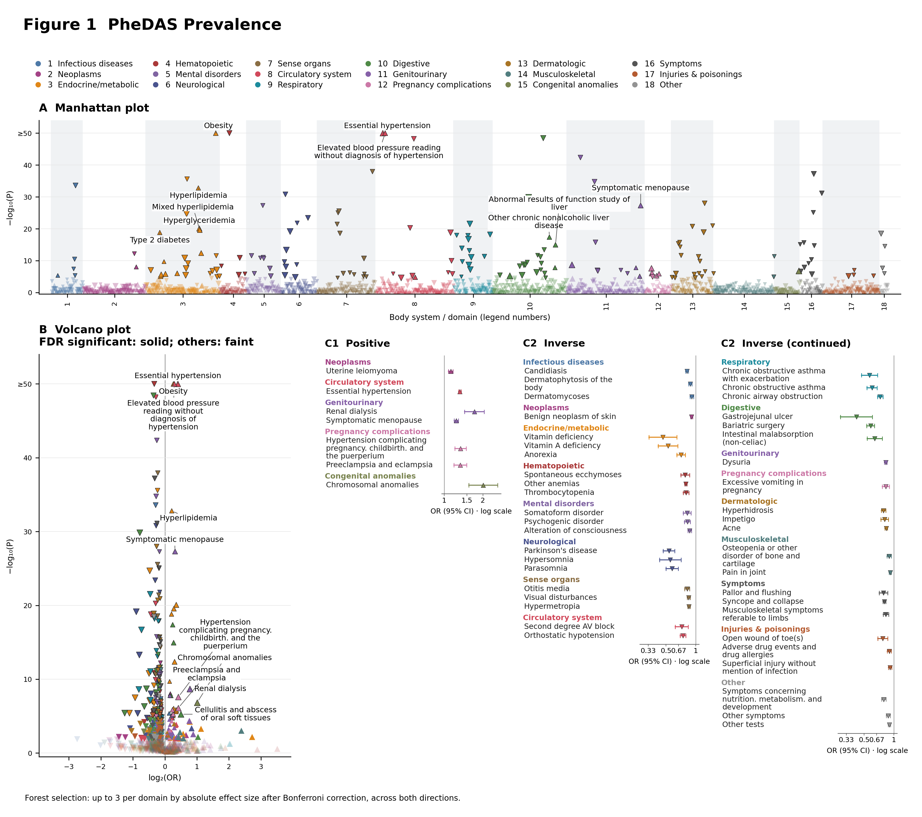
Figure 1. PheDAS Prevalence. A, Manhattan plot; B, volcano plot; C1/C2, positive/inverse forests. Fully adjusted m4_bmi primary AHI ≥5 versus <5 estimates for 1,779 phecodes, excluding sleep apnea and subcodes. Panel B additionally labels essential hypertension, elevated blood pressure, obesity, hyperlipidemia, and symptomatic menopause. Complete results: Supplementary Atlas, PheDAS Prevalence tab. Colors identify body systems or established study domains. Upward/downward triangles indicate positive/inverse effects; size reflects absolute effect magnitude, and dark outlines mark Bonferroni-significant results. Manhattan plots label up to ten positive Bonferroni-significant associations ranked by smallest P value. Volcano plots retain all features: solid symbols indicate FDR-significant features (Benjamini–Hochberg q<0.05), and faint symbols indicate features that do not meet FDR significance. Volcano plots label up to five positive Bonferroni-significant associations ranked by largest effect size (OR, HR, IRR, or positive β), with ties resolved by smallest P value and then label. Inverse associations are not labeled. All qualifying labels are shown when fewer than the limit exist. −log10(P) is capped at 50. Forests show up to three Bonferroni-significant features per body system or established domain, selected across both directions by descending absolute log2 ratio (OR, HR or IRR), or absolute β for continuous outcomes. Ranking is within each domain; selection precedes splitting into positive/inverse panels where shown. Whiskers are 95% CIs; ratio axes use a null of 1 and β axes a null of 0. Original multiplicity flags are retained. C1 contains seven of the 29 positive Bonferroni-significant primary associations. The per-system cap is applied across both directions, so omitted positive findings can be significant; the forests are selected summaries, not exhaustive lists.

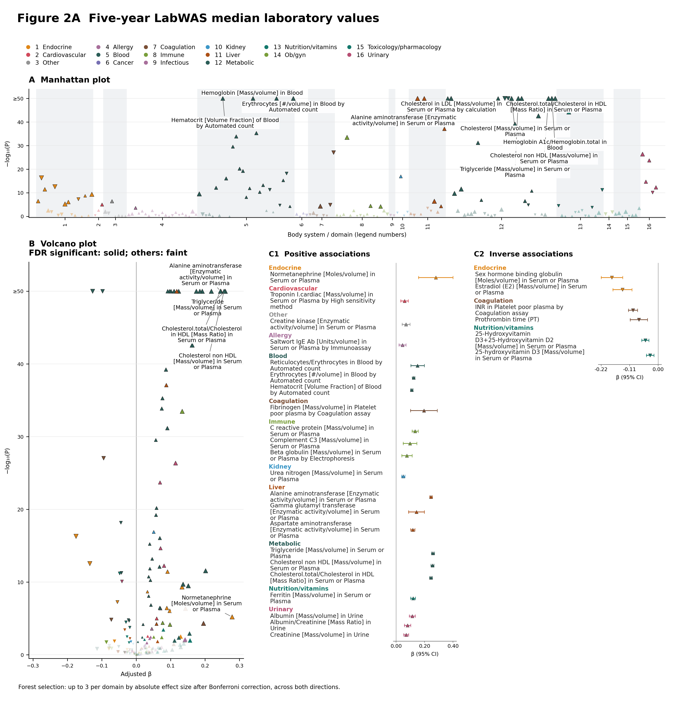
Figure 2A. Five-year LabWAS median laboratory values. A, Manhattan plot; B, volcano plot; C1/C2, positive/inverse forests. 185 analytes with estimable fully adjusted m4 rank-inverse-normal β estimates among measured patients. All contrasts compare AHI ≥5 versus <5. Colors identify laboratory categories. Laboratory values and ordering outcomes are separate estimands and retain their original multiplicity flags. Complete 1- and 5-year results: Supplementary Atlas, LabWAS tab. Colors identify body systems or established study domains. Upward/downward triangles indicate positive/inverse effects; size reflects absolute effect magnitude, and dark outlines mark Bonferroni-significant results. Manhattan plots label up to ten positive Bonferroni-significant associations ranked by smallest P value. Volcano plots retain all features: solid symbols indicate FDR-significant features (Benjamini–Hochberg q<0.05), and faint symbols indicate features that do not meet FDR significance. Volcano plots label up to five positive Bonferroni-significant associations ranked by largest effect size (OR, HR, IRR, or positive β), with ties resolved by smallest P value and then label. Inverse associations are not labeled. All qualifying labels are shown when fewer than the limit exist. −log10(P) is capped at 50. Forests show up to three Bonferroni-significant features per body system or established domain, selected across both directions by descending absolute log2 ratio (OR, HR or IRR), or absolute β for continuous outcomes. Ranking is within each domain; selection precedes splitting into positive/inverse panels where shown. Whiskers are 95% CIs; ratio axes use a null of 1 and β axes a null of 0. Original multiplicity flags are retained.

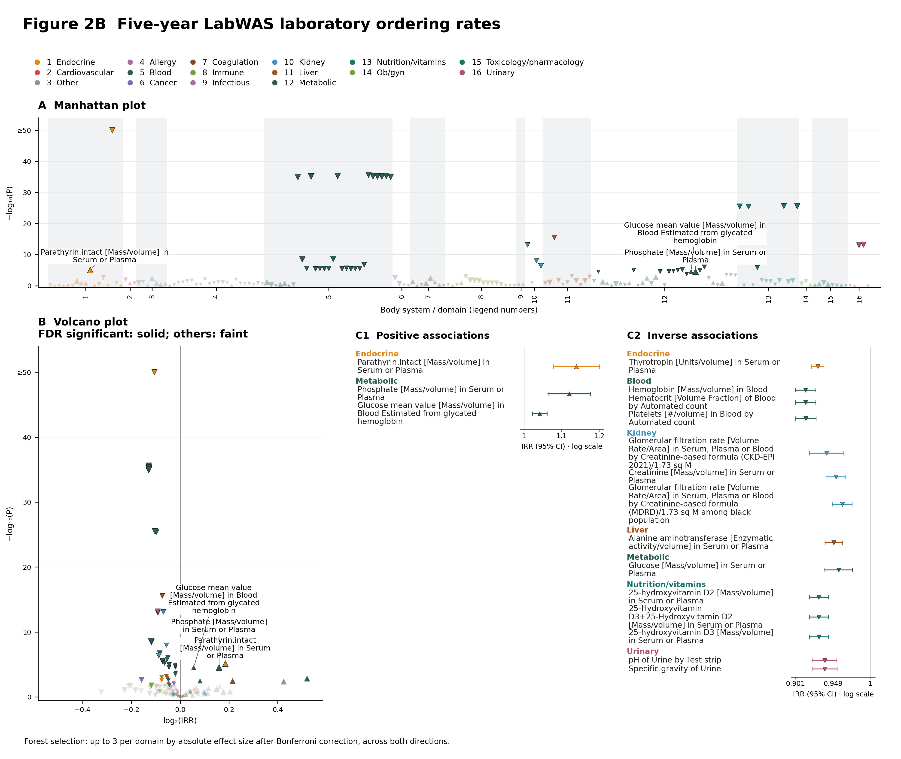
Figure 2B. Five-year LabWAS laboratory ordering rates. A, Manhattan plot; B, volcano plot; C1/C2, positive/inverse forests. 186 analytes with estimable fully adjusted m4 ordering-rate IRRs among patients with laboratory observations. All contrasts compare AHI ≥5 versus <5. Colors identify laboratory categories. Laboratory values and ordering outcomes are separate estimands and retain their original multiplicity flags. Complete 1- and 5-year results: Supplementary Atlas, LabWAS tab. Colors identify body systems or established study domains. Upward/downward triangles indicate positive/inverse effects; size reflects absolute effect magnitude, and dark outlines mark Bonferroni-significant results. Manhattan plots label up to ten positive Bonferroni-significant associations ranked by smallest P value. Volcano plots retain all features: solid symbols indicate FDR-significant features (Benjamini–Hochberg q<0.05), and faint symbols indicate features that do not meet FDR significance. Volcano plots label up to five positive Bonferroni-significant associations ranked by largest effect size (OR, HR, IRR, or positive β), with ties resolved by smallest P value and then label. Inverse associations are not labeled. All qualifying labels are shown when fewer than the limit exist. −log10(P) is capped at 50. Forests show up to three Bonferroni-significant features per body system or established domain, selected across both directions by descending absolute log2 ratio (OR, HR or IRR), or absolute β for continuous outcomes. Ranking is within each domain; selection precedes splitting into positive/inverse panels where shown. Whiskers are 95% CIs; ratio axes use a null of 1 and β axes a null of 0. Original multiplicity flags are retained.

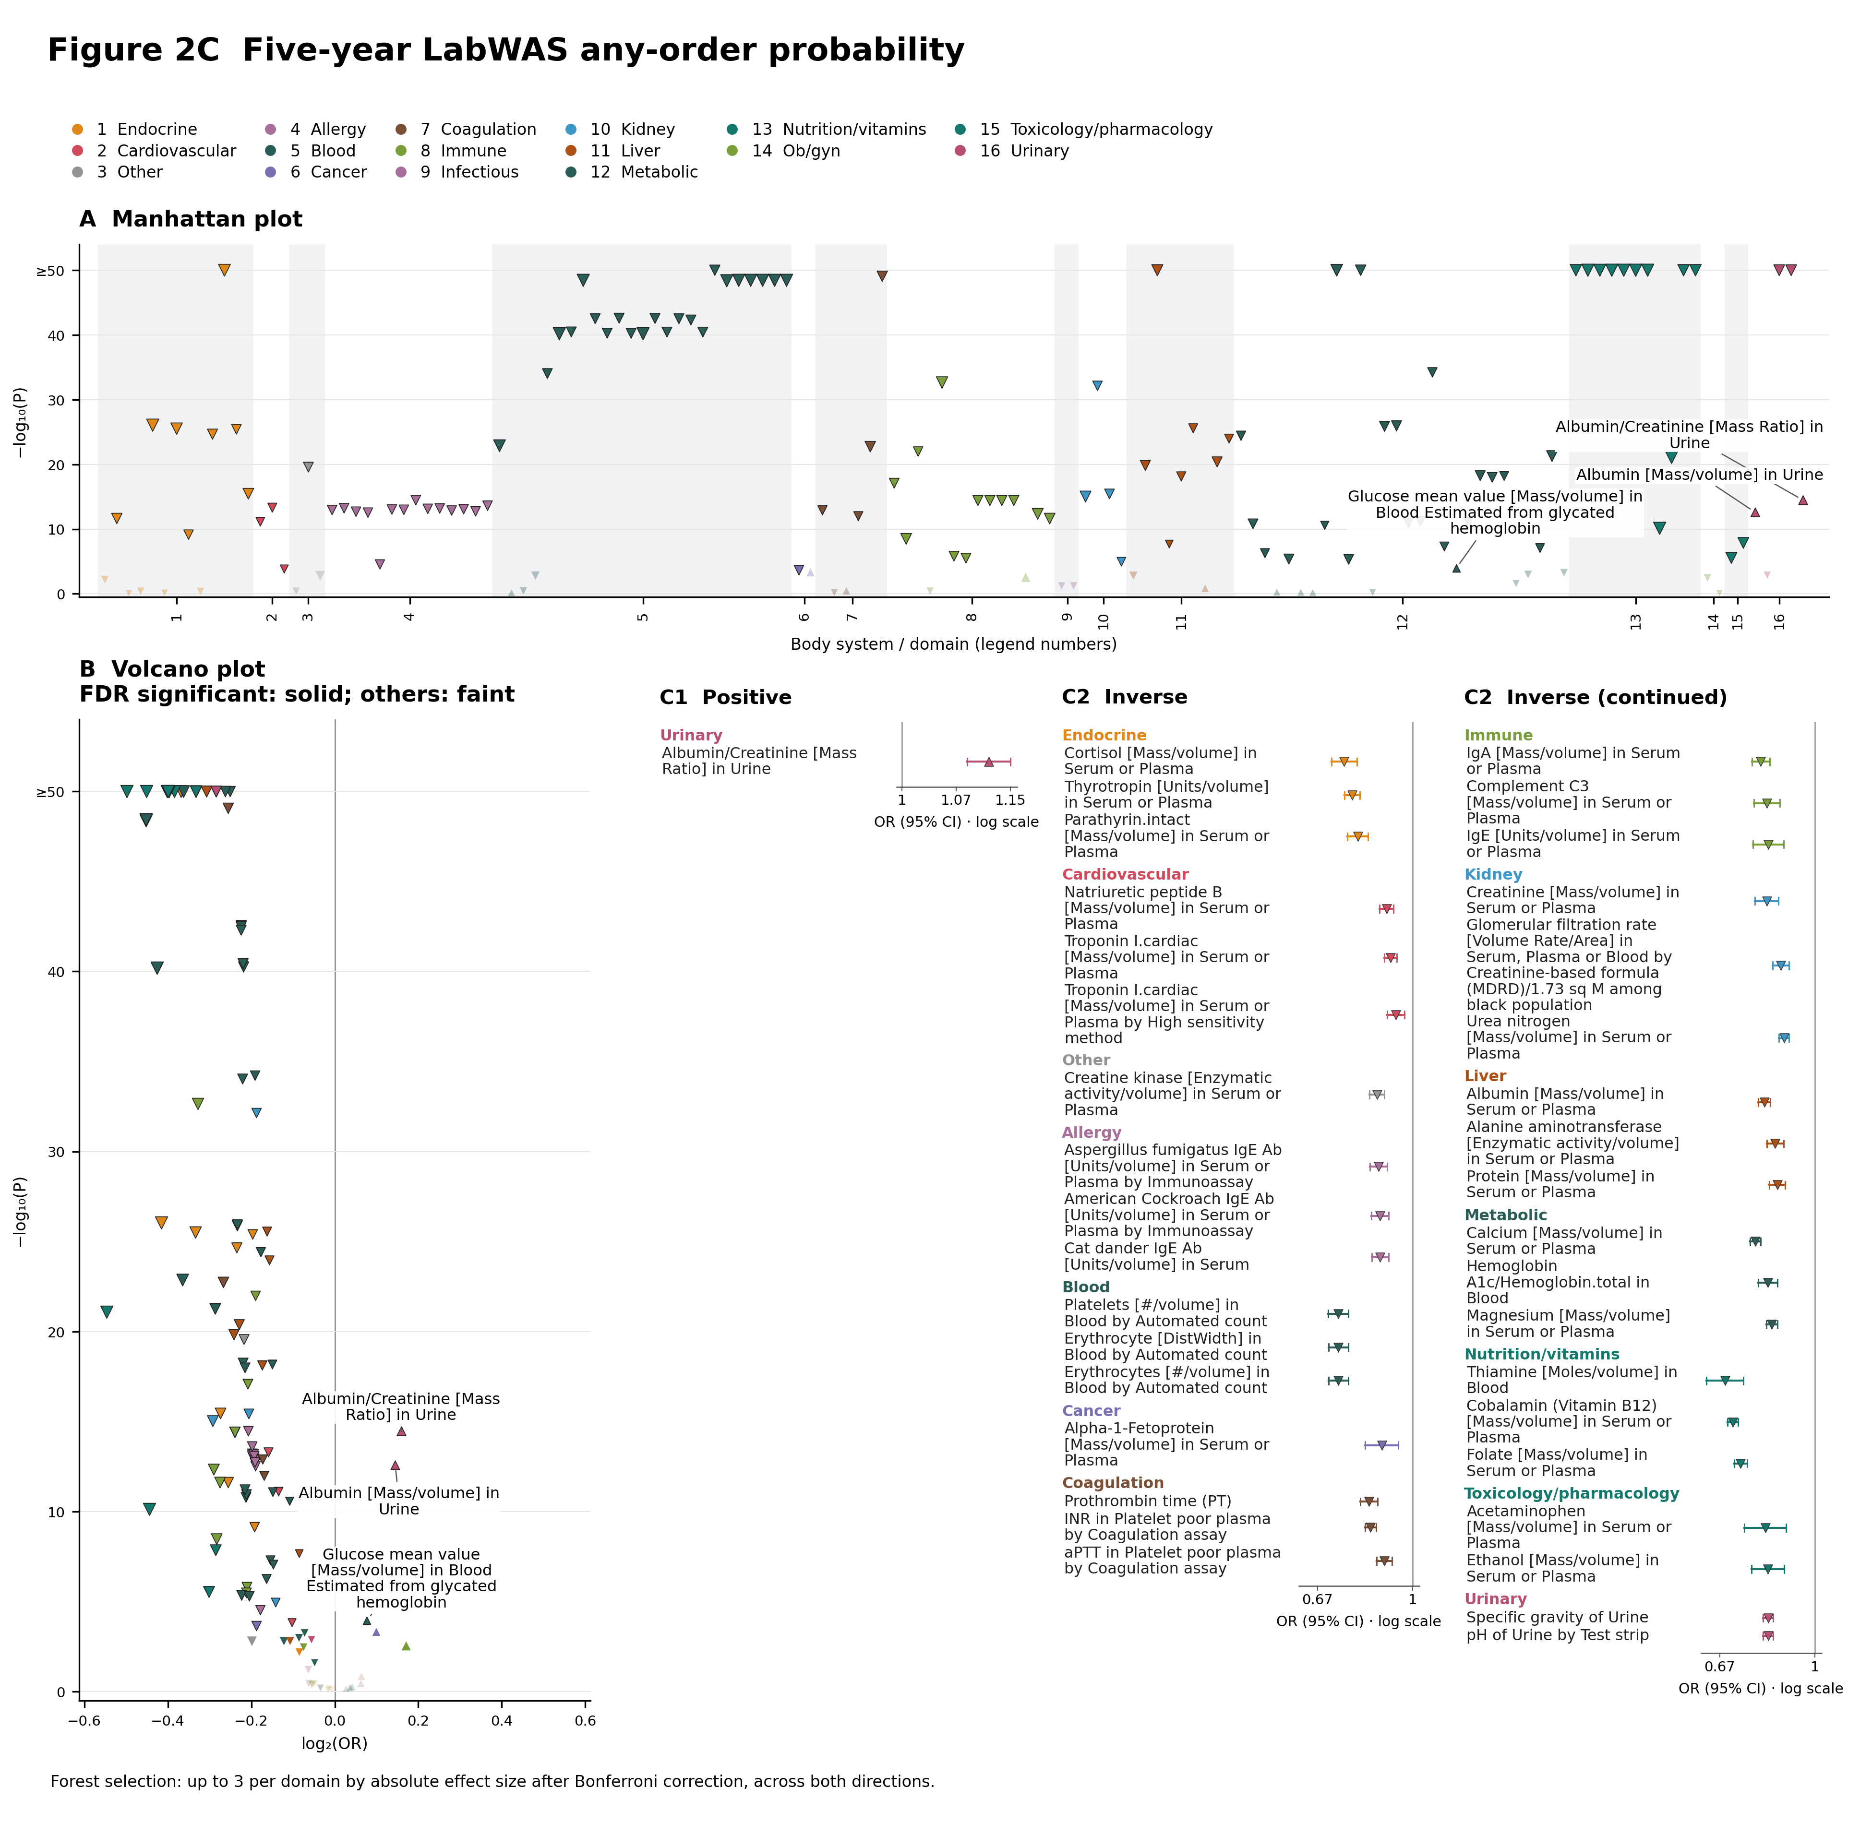
Figure 2C. Five-year LabWAS any-order probability. A, Manhattan plot; B, volcano plot; C1/C2, positive/inverse forests. 143 analytes with estimable fully adjusted m4 odds ratios for any laboratory order; four non-estimable rows are omitted. All contrasts compare AHI ≥5 versus <5. Colors identify laboratory categories. Laboratory values and ordering outcomes are separate estimands and retain their original multiplicity flags. Complete 1- and 5-year results: Supplementary Atlas, LabWAS tab. Colors identify body systems or established study domains. Upward/downward triangles indicate positive/inverse effects; size reflects absolute effect magnitude, and dark outlines mark Bonferroni-significant results. Manhattan plots label up to ten positive Bonferroni-significant associations ranked by smallest P value. Volcano plots retain all features: solid symbols indicate FDR-significant features (Benjamini–Hochberg q<0.05), and faint symbols indicate features that do not meet FDR significance. Volcano plots label up to five positive Bonferroni-significant associations ranked by largest effect size (OR, HR, IRR, or positive β), with ties resolved by smallest P value and then label. Inverse associations are not labeled. All qualifying labels are shown when fewer than the limit exist. −log10(P) is capped at 50. Forests show up to three Bonferroni-significant features per body system or established domain, selected across both directions by descending absolute log2 ratio (OR, HR or IRR), or absolute β for continuous outcomes. Ranking is within each domain; selection precedes splitting into positive/inverse panels where shown. Whiskers are 95% CIs; ratio axes use a null of 1 and β axes a null of 0. Original multiplicity flags are retained.

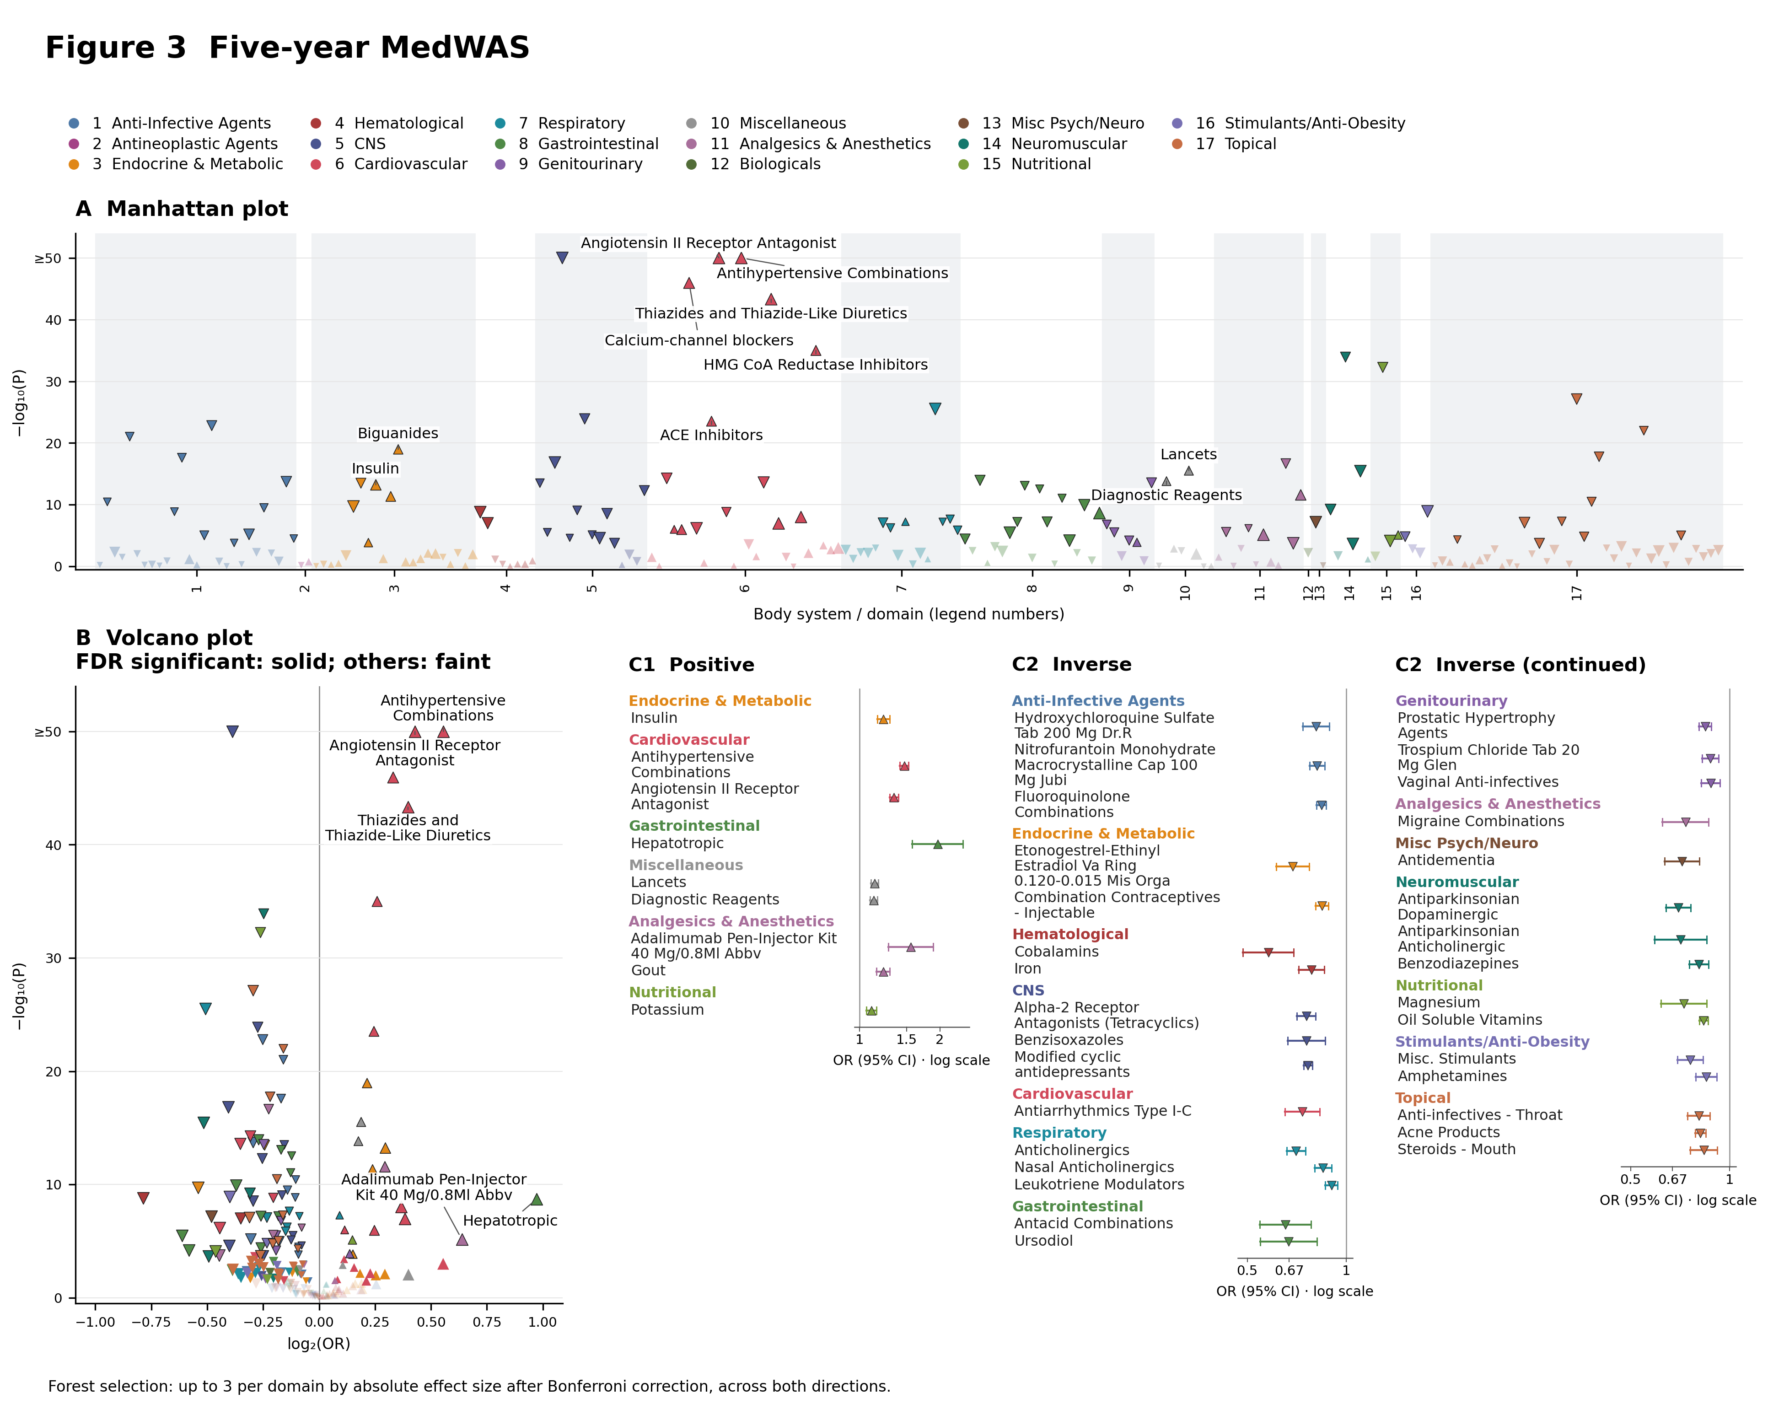
Figure 3. Five-year MedWAS. A, Manhattan plot; B, volcano plot; C1/C2, positive/inverse forests. All 218 medication classes; fully adjusted m4 AHI ≥5 versus <5. Complete results: Supplementary Atlas, MedWAS tab. Colors identify body systems or established study domains. Upward/downward triangles indicate positive/inverse effects; size reflects absolute effect magnitude, and dark outlines mark Bonferroni-significant results. Manhattan plots label up to ten positive Bonferroni-significant associations ranked by smallest P value. Volcano plots retain all features: solid symbols indicate FDR-significant features (Benjamini–Hochberg q<0.05), and faint symbols indicate features that do not meet FDR significance. Volcano plots label up to five positive Bonferroni-significant associations ranked by largest effect size (OR, HR, IRR, or positive β), with ties resolved by smallest P value and then label. Inverse associations are not labeled. All qualifying labels are shown when fewer than the limit exist. −log10(P) is capped at 50. Forests show up to three Bonferroni-significant features per body system or established domain, selected across both directions by descending absolute log2 ratio (OR, HR or IRR), or absolute β for continuous outcomes. Ranking is within each domain; selection precedes splitting into positive/inverse panels where shown. Whiskers are 95% CIs; ratio axes use a null of 1 and β axes a null of 0. Original multiplicity flags are retained.

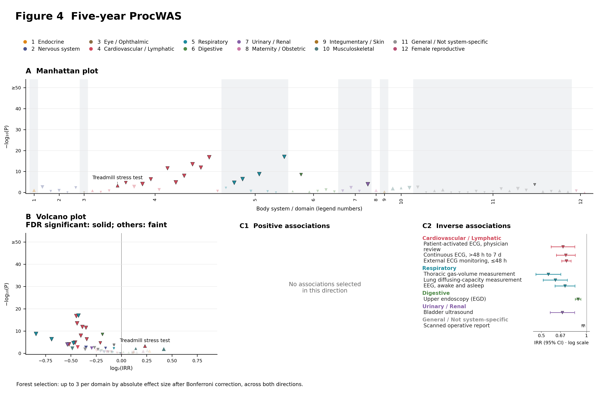
Figure 4. Five-year ProcWAS. A, Manhattan plot; B, volcano plot; C1/C2, positive/inverse forests. All 67 procedures; fully adjusted m4 AHI ≥5 versus <5. Complete results: Supplementary Atlas, ProcWAS tab. Colors identify body systems or established study domains. Upward/downward triangles indicate positive/inverse effects; size reflects absolute effect magnitude, and dark outlines mark Bonferroni-significant results. Manhattan plots label up to ten positive Bonferroni-significant associations ranked by smallest P value. Volcano plots retain all features: solid symbols indicate FDR-significant features (Benjamini–Hochberg q<0.05), and faint symbols indicate features that do not meet FDR significance. Volcano plots label up to five positive Bonferroni-significant associations ranked by largest effect size (OR, HR, IRR, or positive β), with ties resolved by smallest P value and then label. Inverse associations are not labeled. All qualifying labels are shown when fewer than the limit exist. −log10(P) is capped at 50. Forests show up to three Bonferroni-significant features per body system or established domain, selected across both directions by descending absolute log2 ratio (OR, HR or IRR), or absolute β for continuous outcomes. Ranking is within each domain; selection precedes splitting into positive/inverse panels where shown. Whiskers are 95% CIs; ratio axes use a null of 1 and β axes a null of 0. Original multiplicity flags are retained.

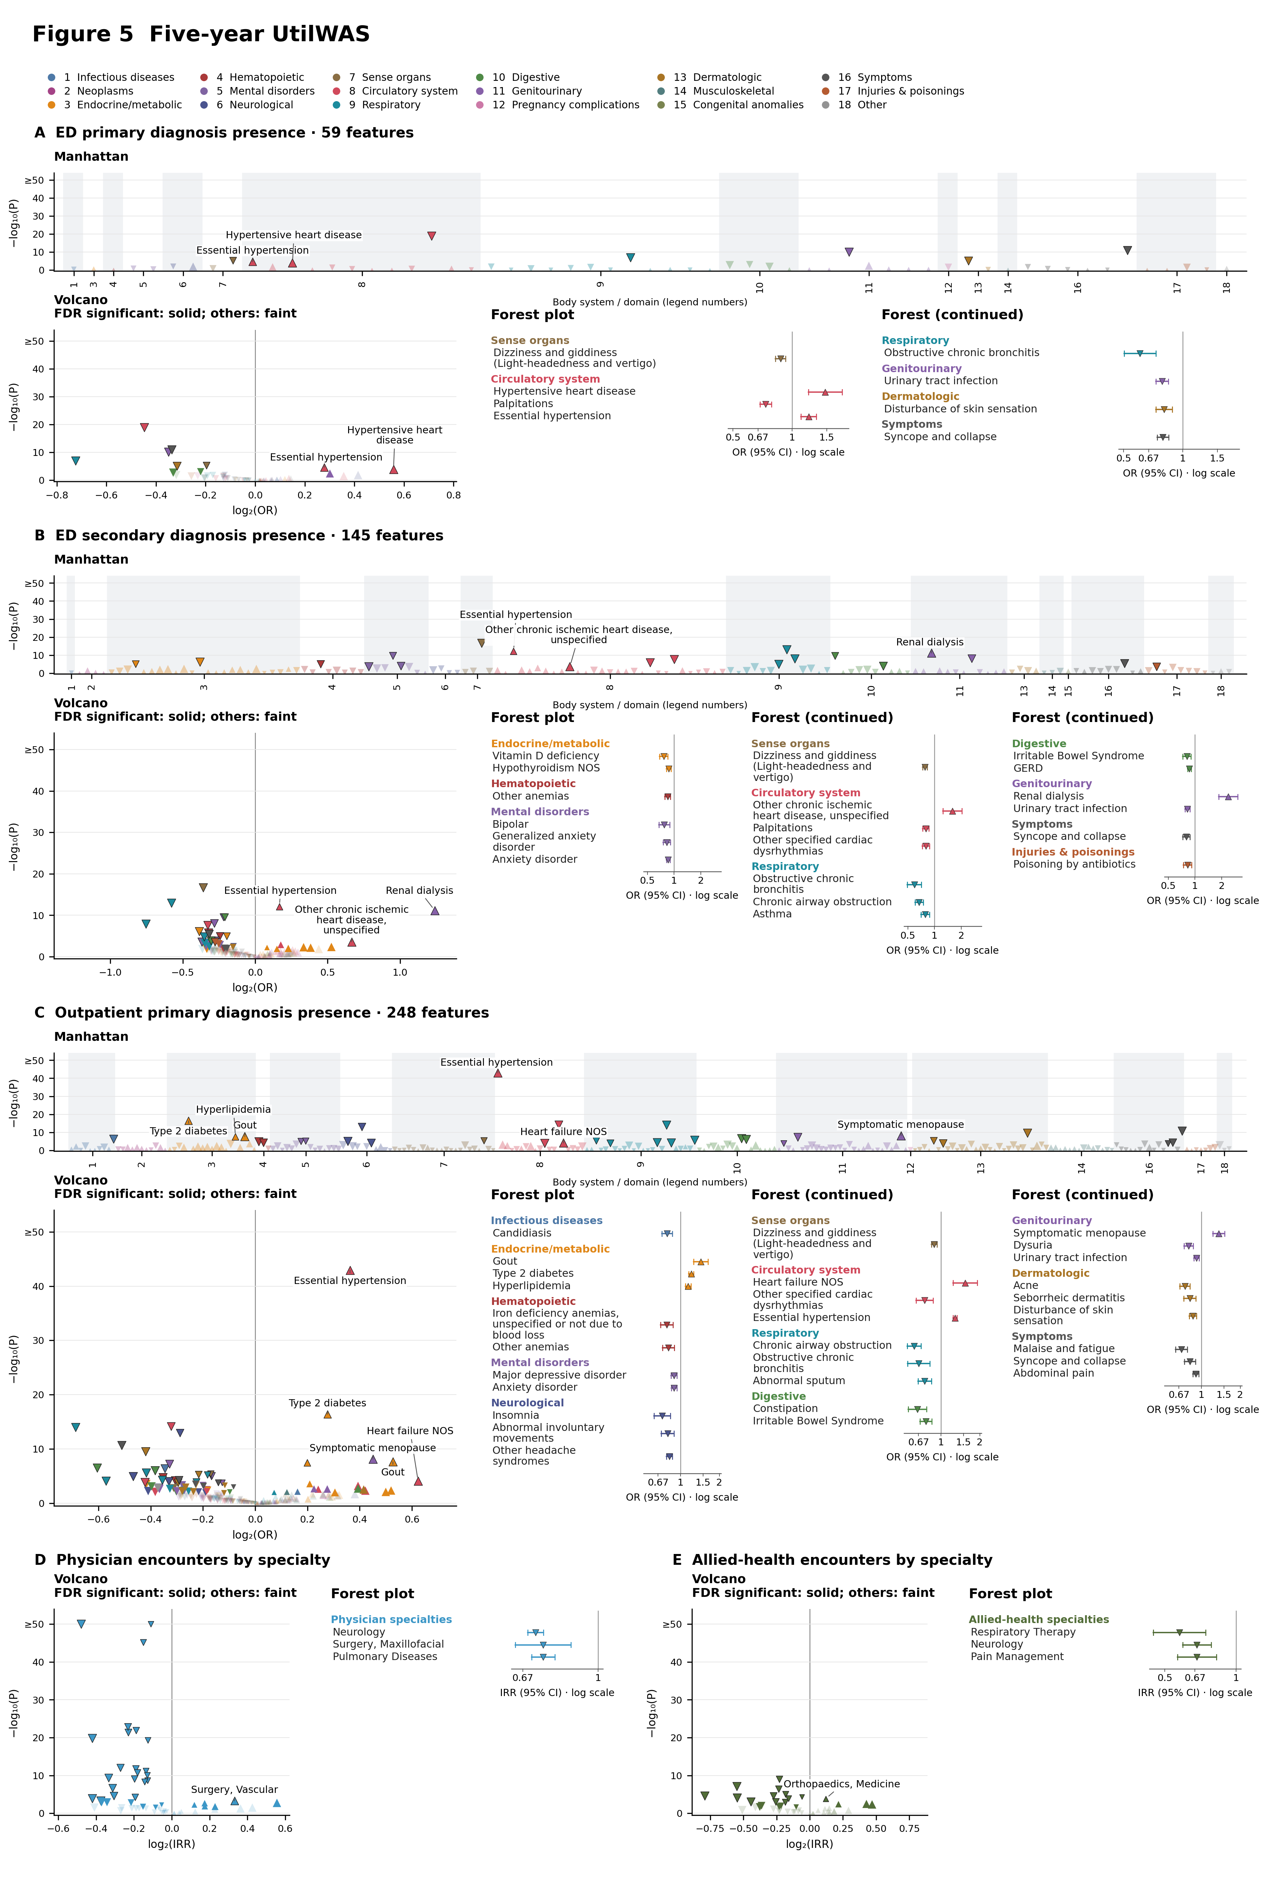
Figure 5. Five-year UtilWAS. A–C combine Manhattan, volcano, and forest plots; D and E show volcano and forest plots only. Five-year fully adjusted m4 estimates compare AHI ≥5 versus <5. A/B, ED-primary/secondary diagnosis presence; C, primary diagnoses associated with outpatient physician encounters; D/E, physician/allied-health encounter rates by specialty. Diagnosis-presence odds ratios use the full cohort. Specialty IRRs describe encounters per person-time and are not diagnosis-conditional rates. Outpatient physician encounters are not restricted to Family Practice, Internal Medicine, or Pediatrics. Diagnosis colors use Phecode body systems; specialty panels retain the source physician and allied-health groups. ED conditional rates are omitted. Original analysis-specific multiplicity flags are retained. Colors identify body systems or established study domains. Upward/downward triangles indicate positive/inverse effects; size reflects absolute effect magnitude, and dark outlines mark Bonferroni-significant results. Manhattan plots label up to ten positive Bonferroni-significant associations ranked by smallest P value. Volcano plots retain all features: solid symbols indicate FDR-significant features (Benjamini–Hochberg q<0.05), and faint symbols indicate features that do not meet FDR significance. Volcano plots label up to five positive Bonferroni-significant associations ranked by largest effect size (OR, HR, IRR, or positive β), with ties resolved by smallest P value and then label. Inverse associations are not labeled. All qualifying labels are shown when fewer than the limit exist. −log10(P) is capped at 50. Forests show up to three Bonferroni-significant features per body system or established domain, selected across both directions by descending absolute log2 ratio (OR, HR or IRR), or absolute β for continuous outcomes. Ranking is within each domain; selection precedes splitting into positive/inverse panels where shown. Whiskers are 95% CIs; ratio axes use a null of 1 and β axes a null of 0. Original multiplicity flags are retained. Complete results: Supplementary Atlas, UtilWAS tab. Specialty Manhattan plots were omitted because the source exports did not include a validated surgical, obstetric/gynecologic, and nonsurgical domain classification.

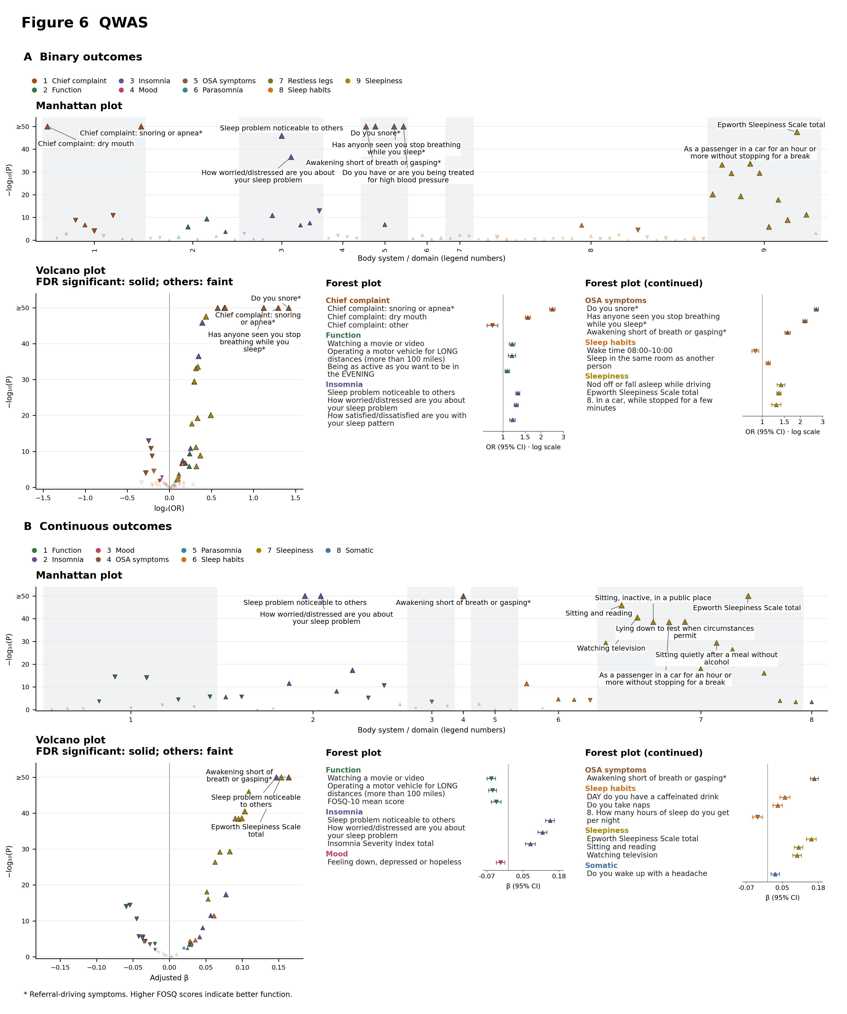
Figure 6. QWAS. A, binary outcomes; B, continuous outcomes. Each section combines Manhattan, volcano, and forest plots. All 83 binary and 49 continuous rows; fully adjusted m4 AHI ≥5 versus <5. Complete results: Supplementary Atlas, QWAS tab. Colors identify body systems or established study domains. Upward/downward triangles indicate positive/inverse effects; size reflects absolute effect magnitude, and dark outlines mark Bonferroni-significant results. Manhattan plots label up to ten positive Bonferroni-significant associations ranked by smallest P value. Volcano plots retain all features: solid symbols indicate FDR-significant features (Benjamini–Hochberg q<0.05), and faint symbols indicate features that do not meet FDR significance. Volcano plots label up to three positive Bonferroni-significant associations ranked by largest effect size (OR, HR, IRR, or positive β), with ties resolved by smallest P value and then label. Inverse associations are not labeled. All qualifying labels are shown when fewer than the limit exist. −log10(P) is capped at 50. Forests show up to three Bonferroni-significant features per body system or established domain, selected across both directions by descending absolute log2 ratio (OR, HR or IRR), or absolute β for continuous outcomes. Ranking is within each domain; selection precedes splitting into positive/inverse panels where shown. Whiskers are 95% CIs; ratio axes use a null of 1 and β axes a null of 0. Original multiplicity flags are retained. * Referral-driving symptoms. Higher FOSQ scores indicate better function.

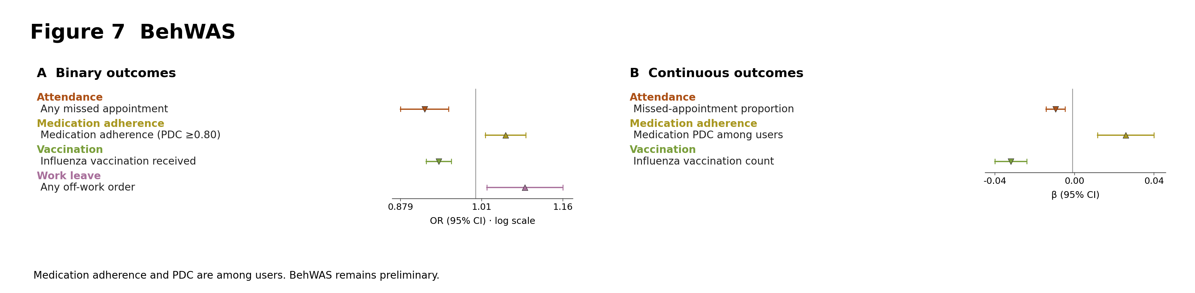
Figure 7. BehWAS. A, binary-outcome forest plot (OR); B, continuous-outcome forest plot (β). Fully adjusted m4 estimates compare AHI ≥5 versus <5. Five-year estimates are used for windowed outcomes and lifetime estimates for undated outcomes. Colors identify medication adherence, vaccination, attendance, and work-leave domains. Forests show selected Bonferroni-significant associations. Medication adherence and PDC are among users. BehWAS remains preliminary. Forests show up to three Bonferroni-significant features per body system or established domain, selected across both directions by descending absolute log2 ratio (OR, HR or IRR), or absolute β for continuous outcomes. Ranking is within each domain; selection precedes splitting into positive/inverse panels where shown. Whiskers are 95% CIs; ratio axes use a null of 1 and β axes a null of 0. Original multiplicity flags are retained. Complete results: Supplementary Atlas, BehWAS tab.

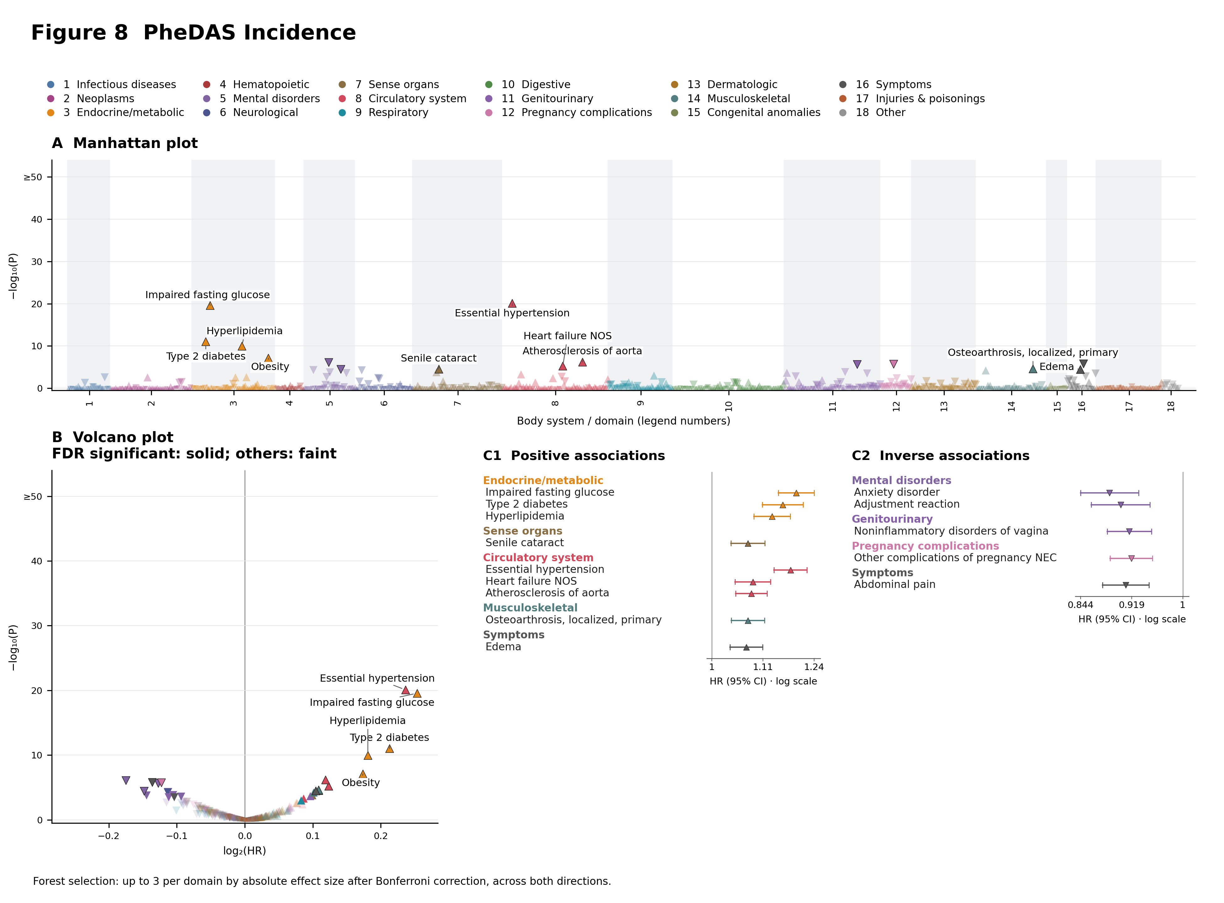
Figure 8. PheDAS Incidence. A, Manhattan plot; B, volcano plot; C1/C2, positive/inverse forests. Fully adjusted m4 primary AHI ≥5 versus <5 estimates for 1,012 phecodes, excluding sleep apnea and subcodes. Complete results: Supplementary Atlas, PheDAS Incidence tab. Colors identify body systems or established study domains. Upward/downward triangles indicate positive/inverse effects; size reflects absolute effect magnitude, and dark outlines mark Bonferroni-significant results. Manhattan plots label up to ten positive Bonferroni-significant associations ranked by smallest P value. Volcano plots retain all features: solid symbols indicate FDR-significant features (Benjamini–Hochberg q<0.05), and faint symbols indicate features that do not meet FDR significance. Volcano plots label up to five positive Bonferroni-significant associations ranked by largest effect size (OR, HR, IRR, or positive β), with ties resolved by smallest P value and then label. Inverse associations are not labeled. All qualifying labels are shown when fewer than the limit exist. −log10(P) is capped at 50. Forests show up to three Bonferroni-significant features per body system or established domain, selected across both directions by descending absolute log2 ratio (OR, HR or IRR), or absolute β for continuous outcomes. Ranking is within each domain; selection precedes splitting into positive/inverse panels where shown. Whiskers are 95% CIs; ratio axes use a null of 1 and β axes a null of 0. Original multiplicity flags are retained.

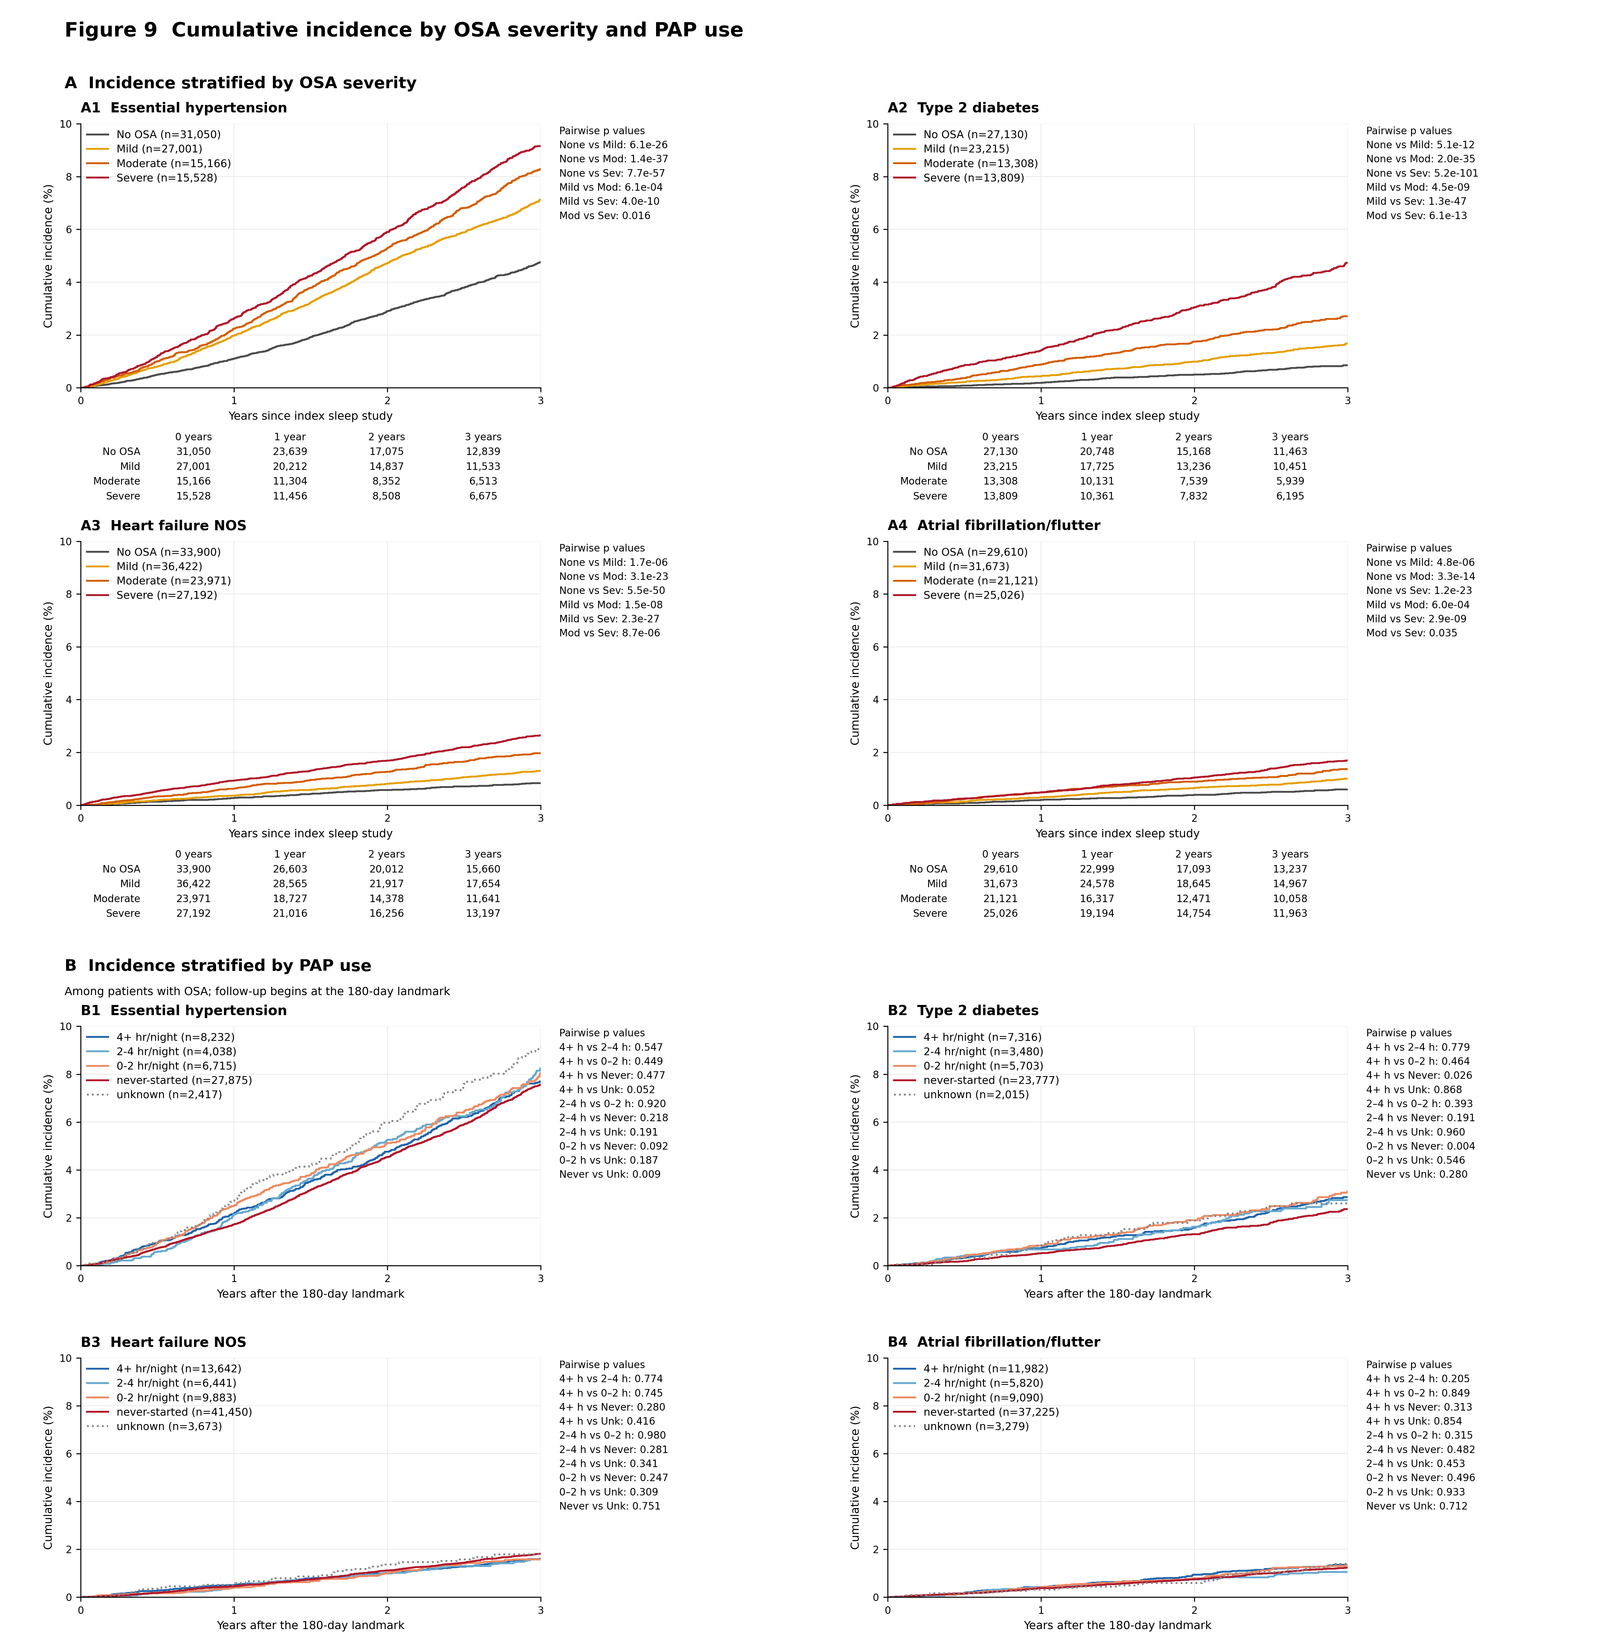
Figure 9. Aalen–Johansen cumulative incidence with death as a competing event. A, incidence stratified by OSA severity; A1–A4 show essential hypertension (401.1), type 2 diabetes (250.2), heart failure NOS (428.2), and atrial fibrillation/flutter (427.2), respectively. Numbers at risk at 0, 1, 2, and 3 years are shown below each severity plot. B, incidence for the same outcomes (B1–B4, respectively) after the 180-day landmark among patients with OSA, stratified by PAP-use category; unknown adherence is dotted. The PAP legends show numbers at risk at the landmark. Curves retain every incident-event step over the displayed three-year horizon and are crude, descriptive estimates. The fully adjusted PAP-use comparisons for these four outcomes were not significant after Bonferroni correction or the secondary FDR correction. All eight plots use a common 0–10% y-axis. Pairwise p values are unadjusted, two-sided cause-specific log-rank tests through three years, with competing deaths censored; they are not multiplicity-adjusted or Gray tests of cumulative-incidence equality. All six severity and all ten PAP-use group pairs are shown per outcome. Pairwise-table abbreviations: None, No OSA; Mod, moderate; Sev, severe; h, hours/night; Never, never started; Unk, unknown adherence.

Figure 10. Clinical signature of the eight cross-domain phenotype octants. All 26 release-audited aggregate measures are shown across the eight octants. Cell values are native-unit means or percentages; color shows standardized difference from the shared cohort, and each cell lists its feature-specific n. Denominators are 70,880 for most phenotype measures, 53,012 for demographics, and 25,380 for follow-up and encounter measures. The octants are regions of continuous burden gradients, not discrete biological classes.

Figure 11. Phenotype-associated disease incidence. All six Bonferroni-significant fully adjusted m4 cause-specific Cox contrasts are shown with 95% CIs. Of 368 eligible phecodes, 15 passed the nominal 7-df omnibus gate (P<0.05), generating 120 one-versus-rest contrasts. Each focal phenotype is compared with its pooled other seven phenotypes. Benjamini–Hochberg FDR and Bonferroni corrections were applied within each focal-phenotype family across the 15 gated outcomes. Filled diamonds identify Bonferroni-significant contrasts. Fourteen contrasts met the secondary FDR criterion and remain available in the Supplementary Atlas. The dashed line marks HR=1; daggers identify fewer than ten events per model parameter. Estimates are observational and do not establish causal effects. All 120 contrasts are in the Supplementary Atlas, PheDAS Incidence tab (phenotype analyses).

Figure 12. Heart failure NOS (Phecode 428.2) cumulative incidence across eight OSA phenotypes and No OSA. Each OSA phenotype is compared with its pooled other seven OSA phenotypes; No OSA (AHI <5) is compared with all eight OSA phenotypes pooled. The same No OSA curve is added as a blue dotted reference in each OSA phenotype panel, with shading for its pointwise 95% confidence interval. The No OSA panel uses the same blue dotted style without duplicating its curve; all original focal and pooled confidence intervals and statistical comparators are unchanged. Unadjusted, tie-aware Aalen–Johansen curves treat death as a competing risk. Shading denotes pointwise 95% confidence intervals from infinitesimal-jackknife variance with a log-log transformation. Panel p values are unadjusted cause-specific log-rank tests through three years, censoring competing deaths; they are not multiplicity-adjusted or Gray tests of cumulative-incidence equality. The OSA curve cohort excludes 154 original phenotype-cohort participants with index AHI <5, retaining the original phenotype assignments and cutpoints. No OSA uses eligible participants from the full incidence follow-up cohort. Median AHI describes each focal baseline risk set after outcome-specific exclusions. M4 HRs (95% CIs) are existing adjusted one-versus-rest estimates from the original phenotype cohort and have EPV<10. No matching M4 estimate is available for No OSA versus the pooled eight phenotypes. The three-year tail is sparse; comparisons are descriptive and do not establish causal effects.

